|  |  |  |  |  |  |
| --- | --- | --- | --- | --- | --- |
| Date | 23-Nov-22 | | | Tester Name | Mohammad Yusuf |
| Environment | Select Environment | | | Login used |  |
| Operating System | Select OS | Version: | Update: | | |
| Software Used | Select Software | Version: | Update: | | |
| Select Software | Version: | Update: | | |
| Release version |  | | | | |
| Title | M33.03 Add additional Tax | | | | |
| Test Type | Regression | | | | |
| Test Scenario | Add additional Tax | | | | |
|  |  | | | | |
| Expected Results |  | | | | |
| Pass/Fail | Select | | | JIRA# | N/A |

Describe your steps with screenshots:

Person profile

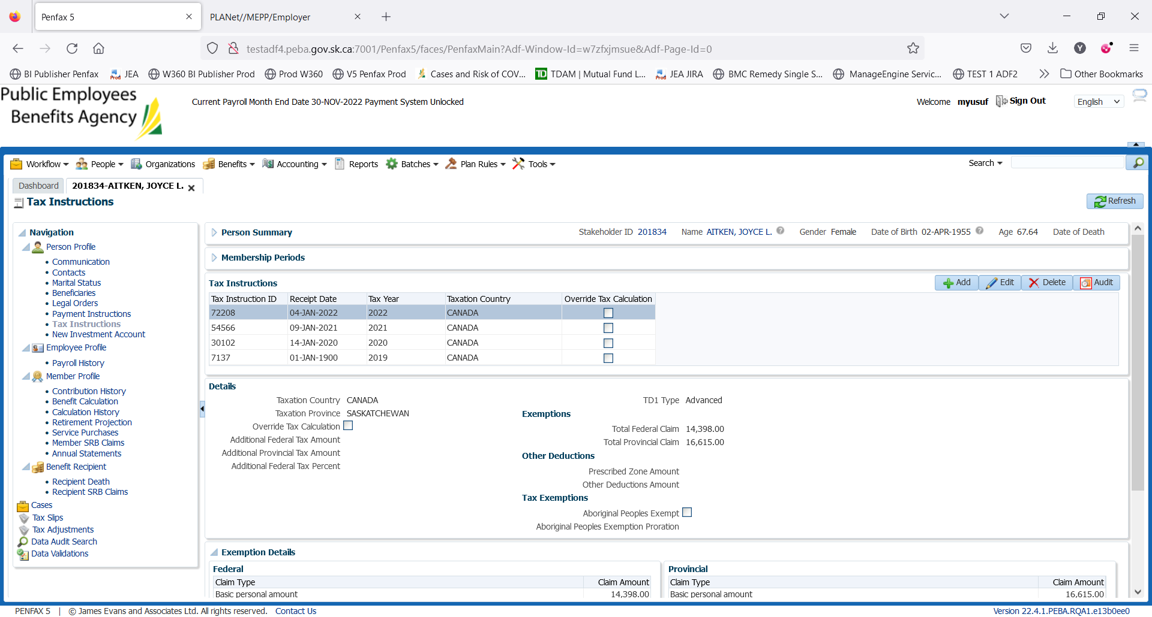

BR

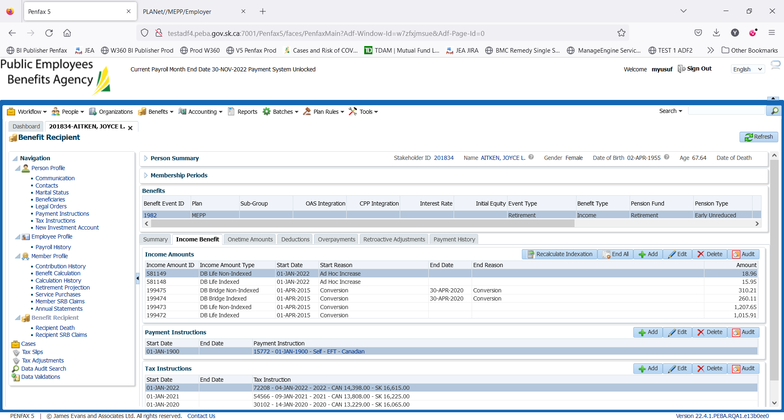

Add new tax instruction same as before, with additional taxes added to it and click save

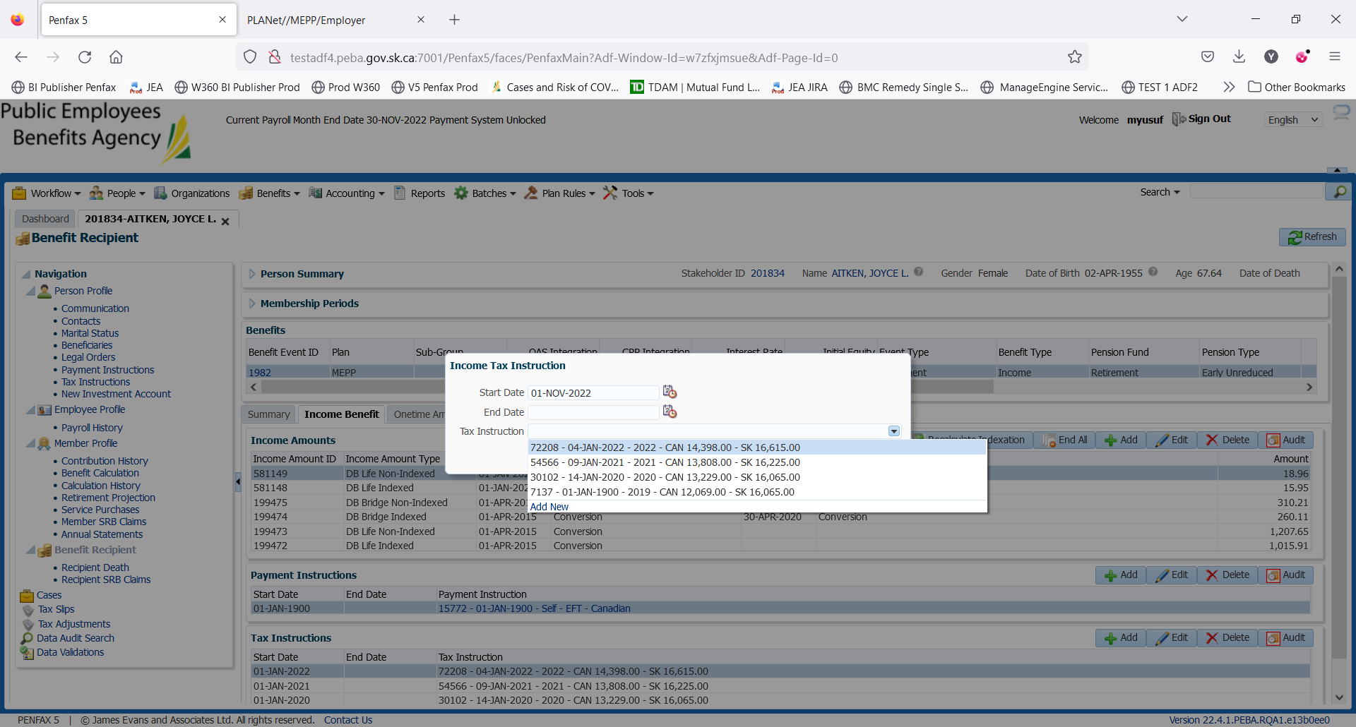

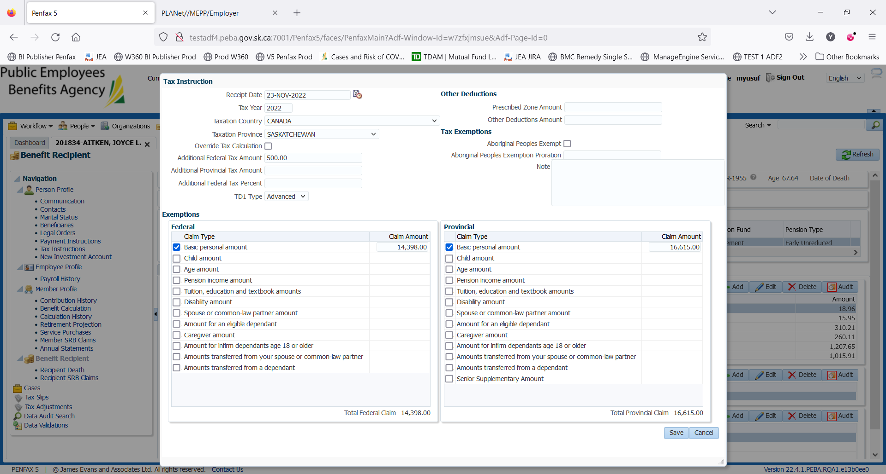

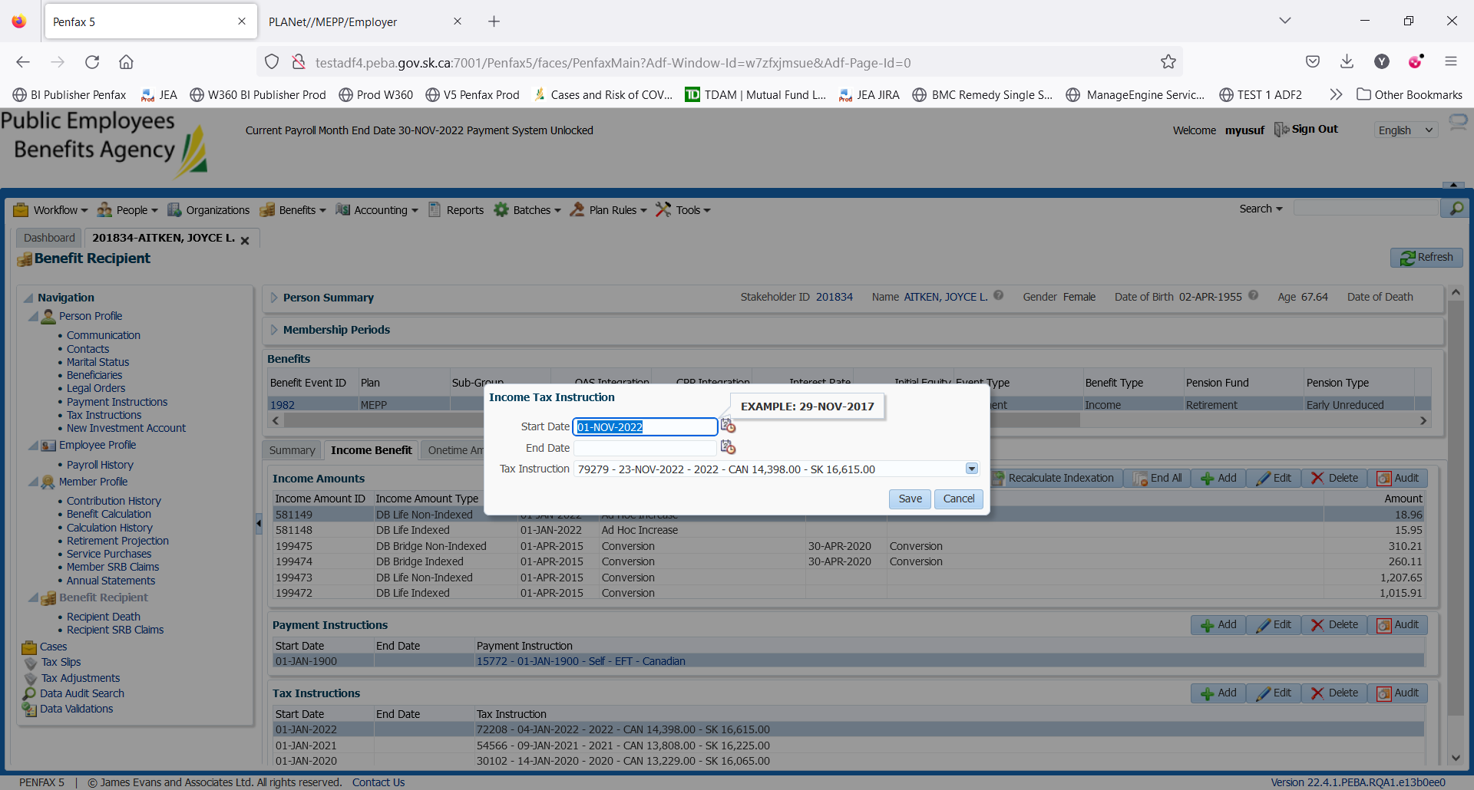

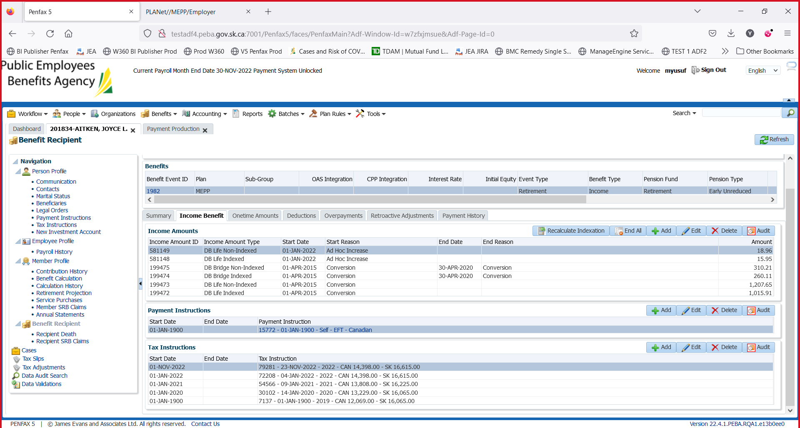

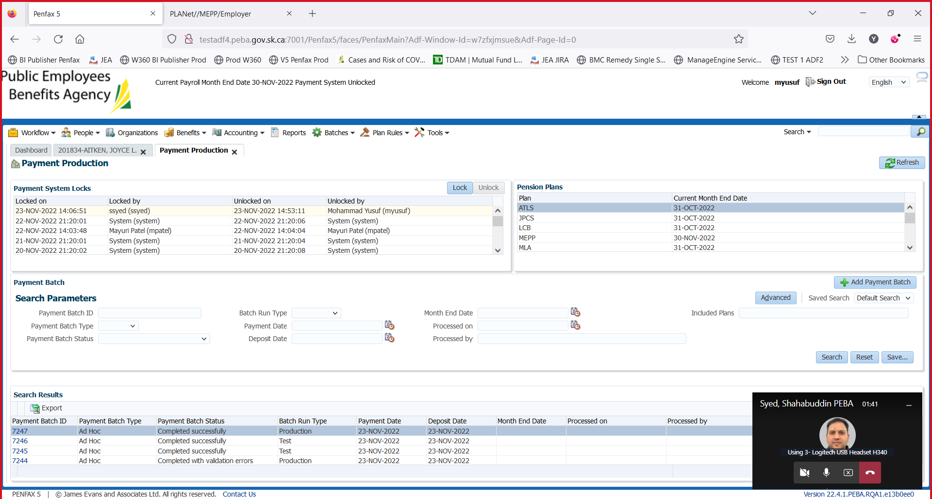

Link the new TI to BR

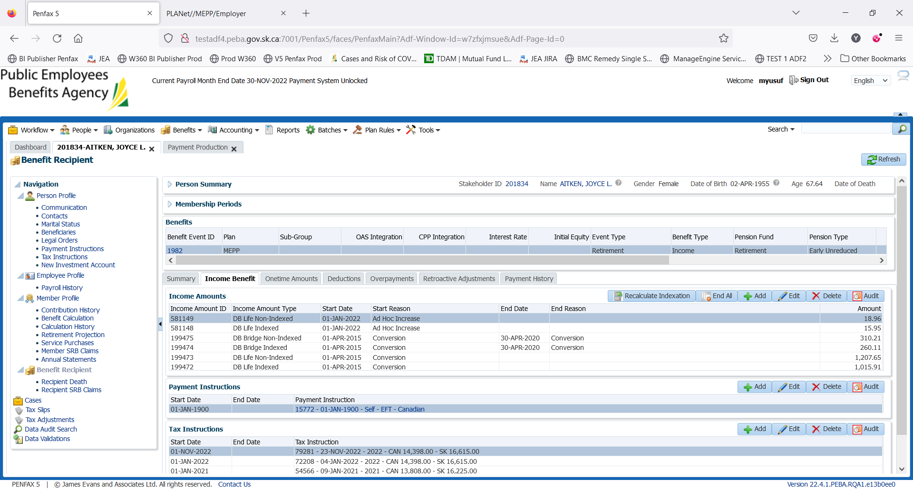

Save

Verify additional taxes comes off in Nov month end payment

$200 additional federal tax deducted

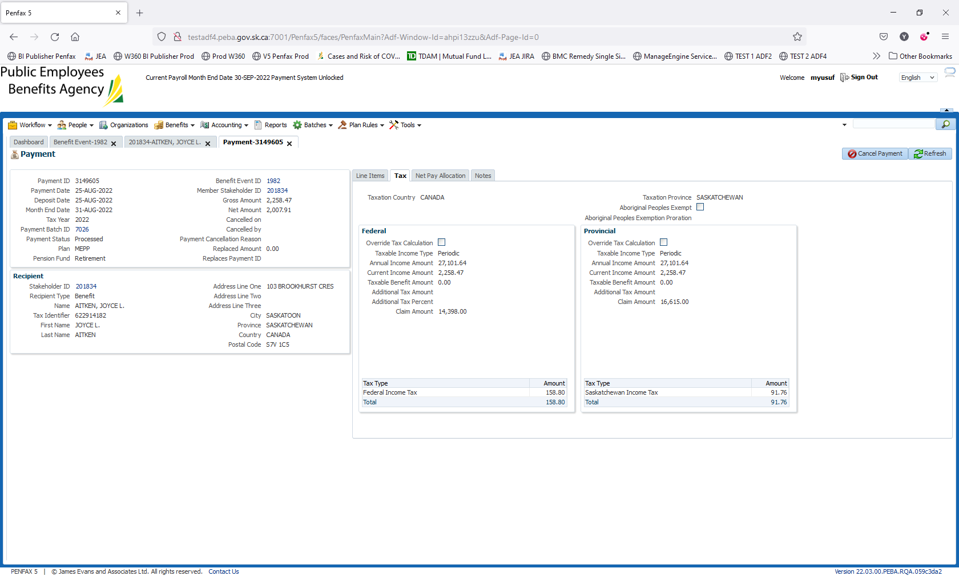

Can not verify the details fo r September as the payment batch has not been run. It may affect other team members testing.